

**NETWORKING & SYSTEM ADMINISTRATION LAB**

**Experiment No.: 8**

**Aim**

Write a shell scripting program to print the basic details.

**Procedure**

#!/bin/bash

echo "Enter the name:"

read name

echo "Enter the age:"

read age

echo "Enter the class:"

read class

echo "Enter the roll no:"

read roll

echo "Enter the place:"

read place

echo "The name is $name"

echo "The age is $age"

echo "The class is $class"

echo "The roll no. is $roll"

echo "The place is $place"

**Output**

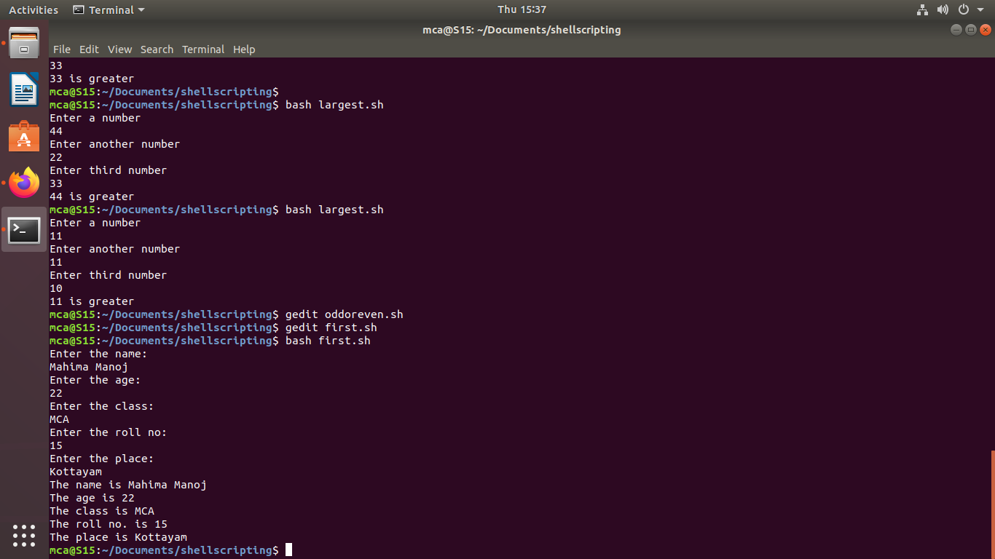

**Aim**

Write a shell scripting program to find the sum of two numbers.

**Procedure**

#!/bin/bash

echo "Enter a number"

read num1

echo "Enter another number"

read num2

sum=$(($num1+$num2))

echo "The sum of $num1 and $num2 is $sum"

if [ $sum -ge 0 ]

then

echo "$sum is greater than 0"

else

echo "$sum is lesser than 0"

fi

**Output**

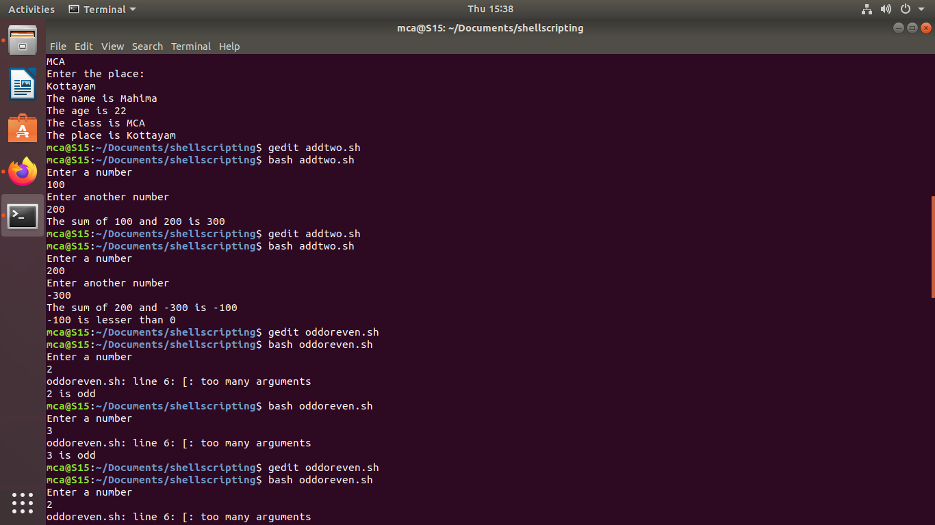

**Aim**

Write a shell scripting program to find the largest of two numbers.

**Procedures**

#!/bin/bash

echo "Enter a number"

read num1

echo "Enter another number"

read num2

sum=$(($num1+$num2))

echo "The sum of $num1 and $num2 is $sum"

if [ $sum -ge 0 ]

then

echo "$sum is greater than 0"

else

echo "$sum is lesser than 0"

fi

**Output**

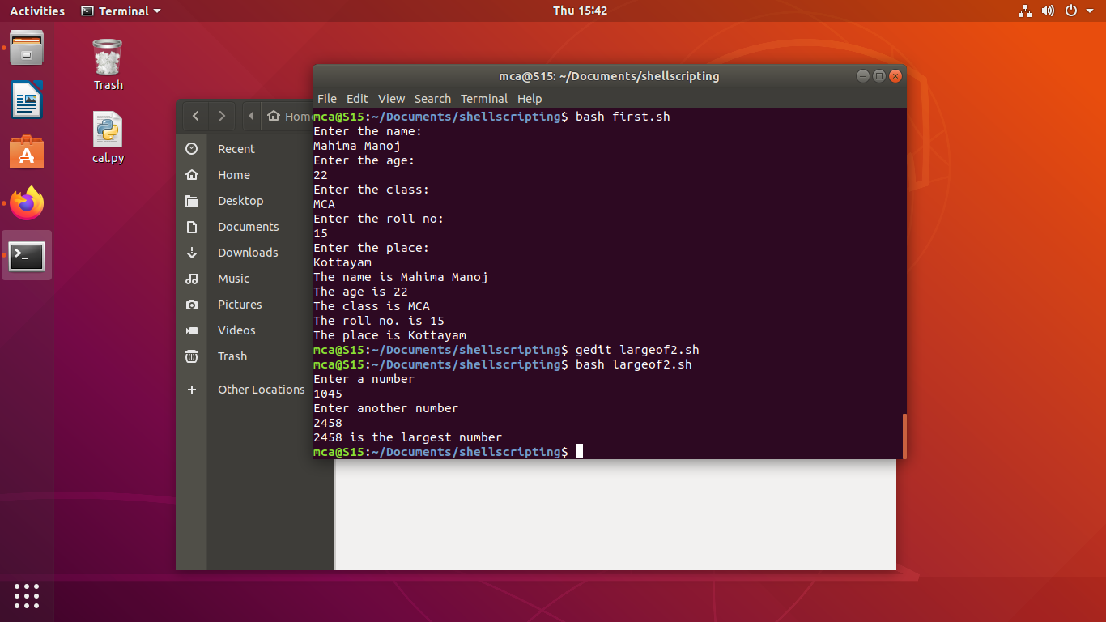

**Aim**

Write shell scripting program to find the largest among three numbers.

**Procedures**

#!/bin/bash

echo "Enter a number"

read num1

echo "Enter another number"

read num2

echo "Enter third number"

read num3

if [ $num1 -ge $num2 -a $num1 -ge $num3 ]

then

echo "$num1 is greater"

elif [ $num2 -ge $num3 ]

then

echo "$num2 is greater"

else

echo "$num3 is greater"

fi

**Output**



**Aim**

Write a shell scripting program to find the number is odd or even

**Procedure**

#!/bin/bash

echo "Enter a number"

read num

evodd=$(($num % 2))

if [ $evodd -eq 0 ]

then

echo "$num is even"

else

echo "$num is odd"

fi

**Output**

